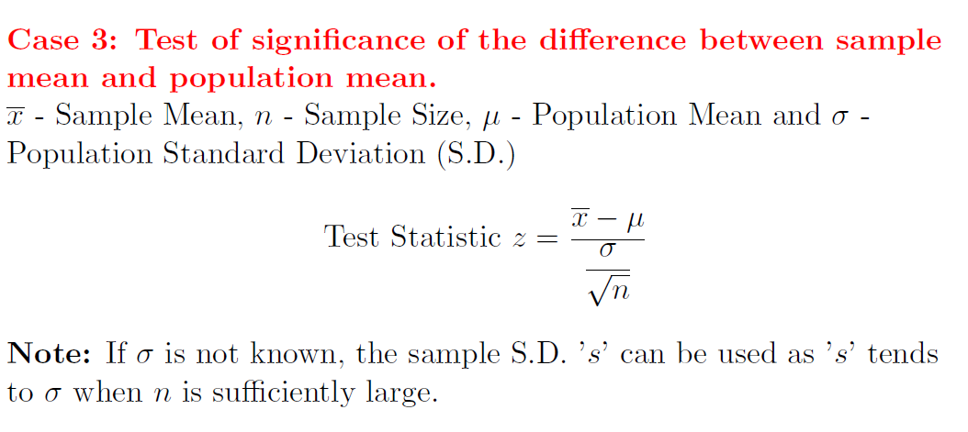

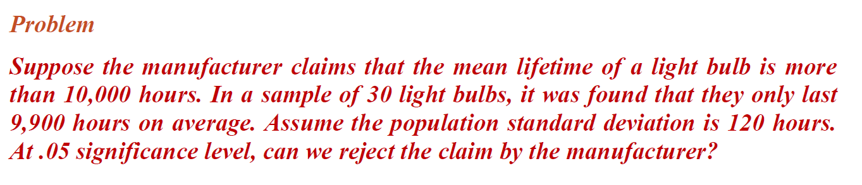

H0 : u>=1000  
H1 : u<=1000 (left tailed test)

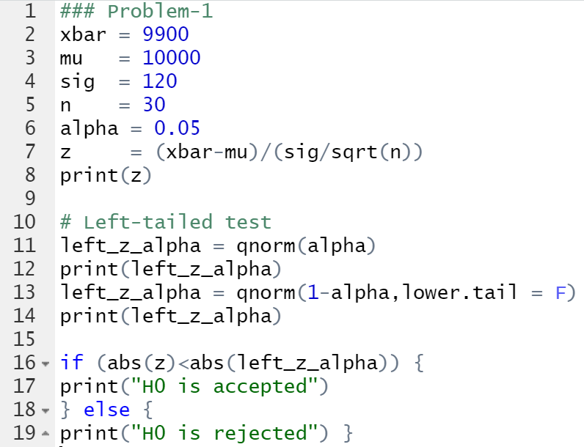

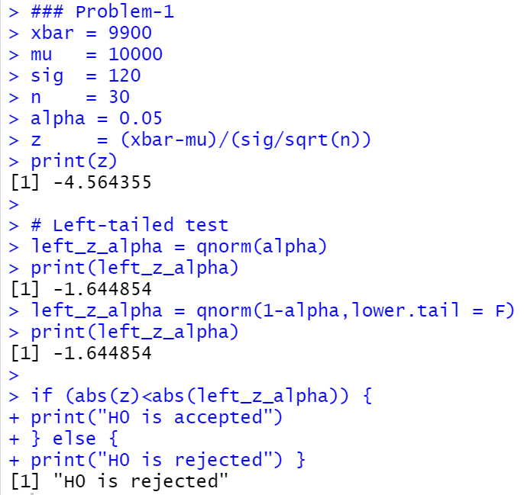

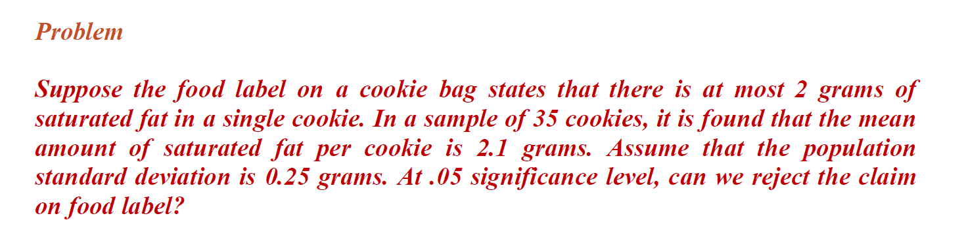

H0 : u<=2  
H1 : u>=2 (Left tailed test)

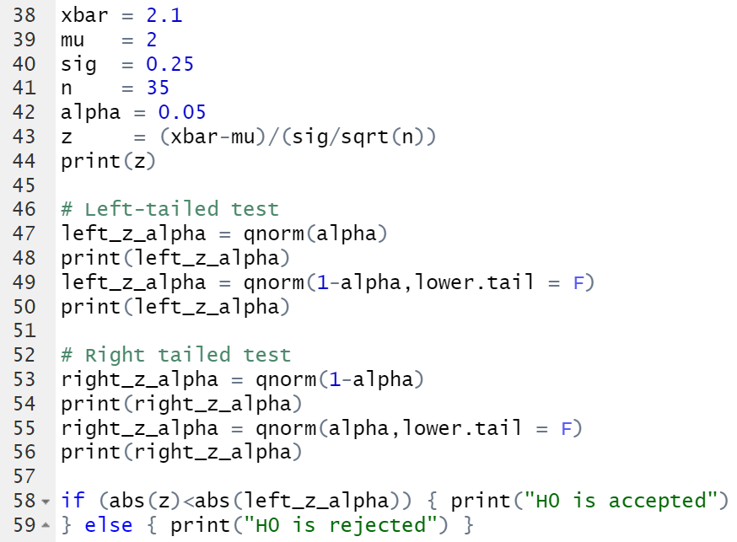

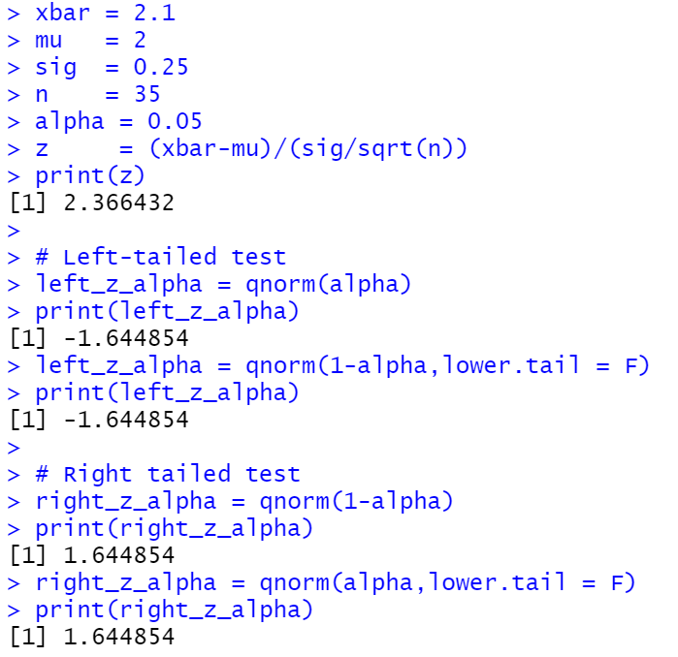  
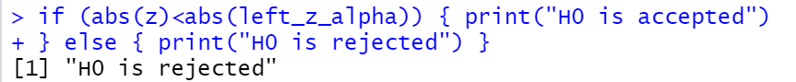

3)

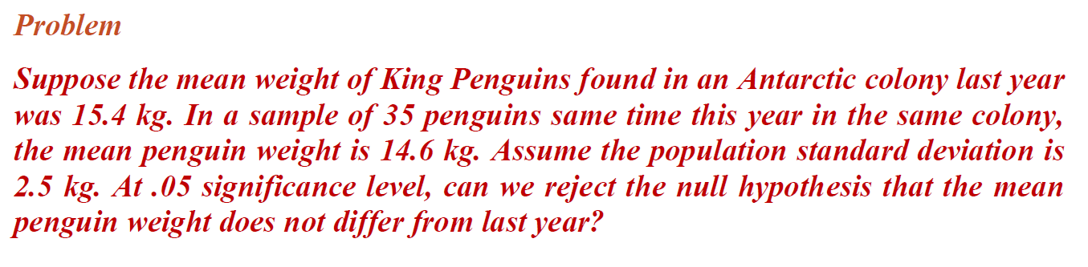

H0 : u=15.4  
H1 : u=15.4 (Two tailed test)



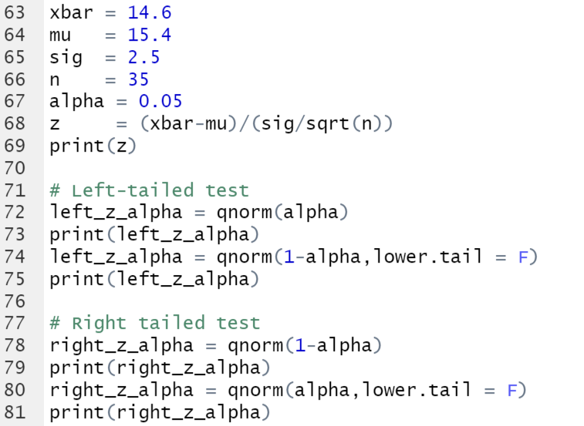  
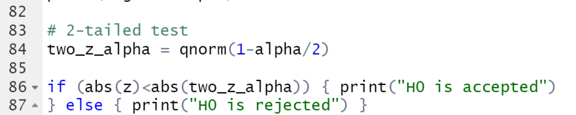

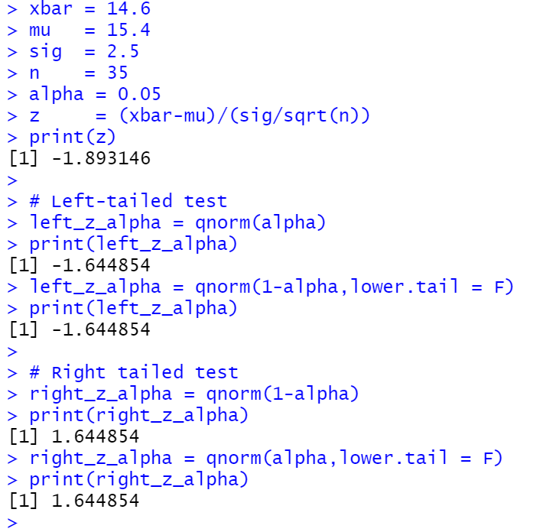  
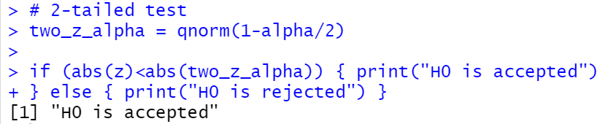

4)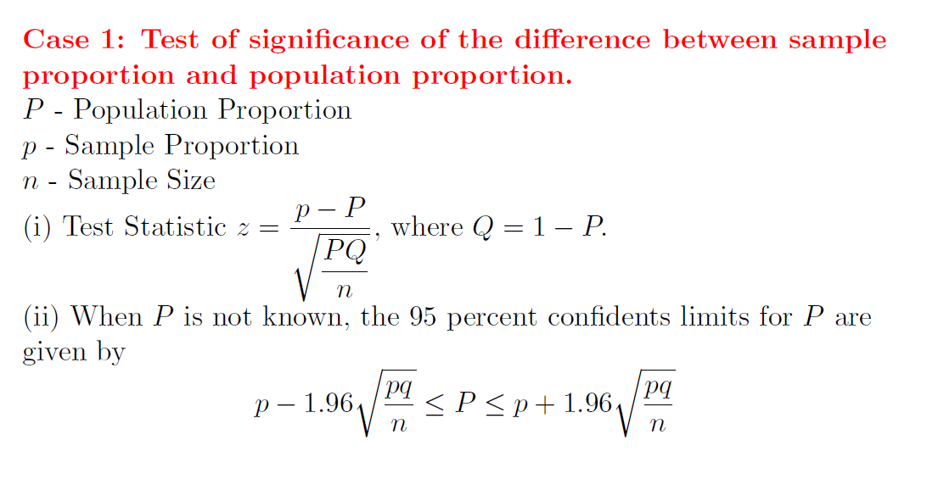

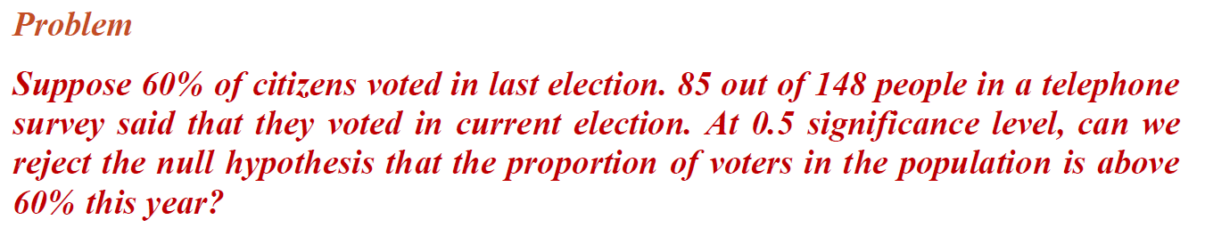

H0 : p>=60%  
H1 : p<=60% (left tailed test)

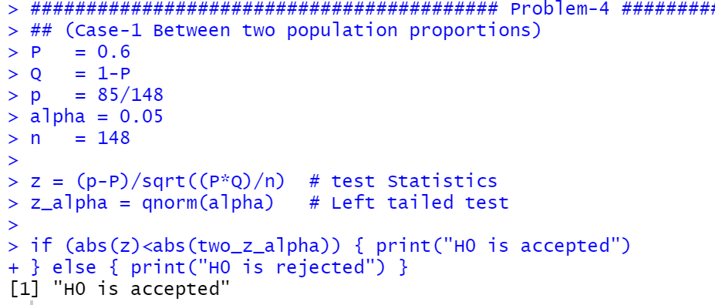

5)

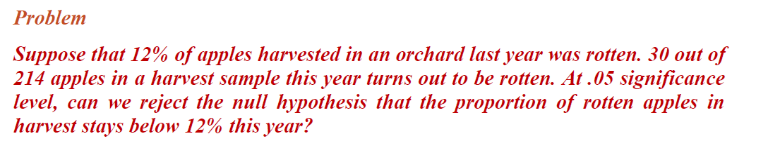

H0 : p<=12%  
H1 : p>=12% (right tailed test)

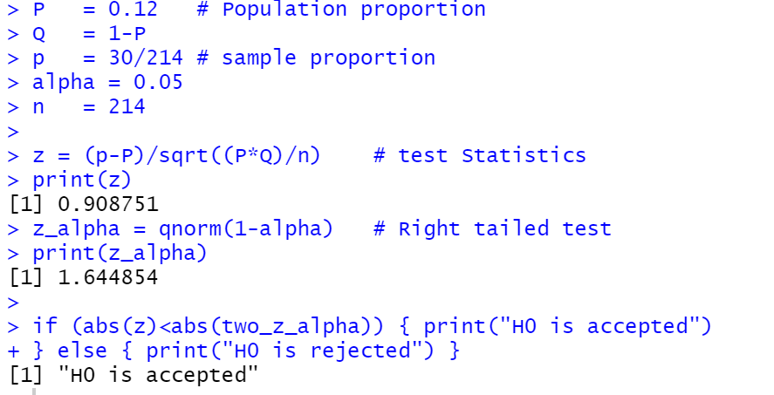

6)

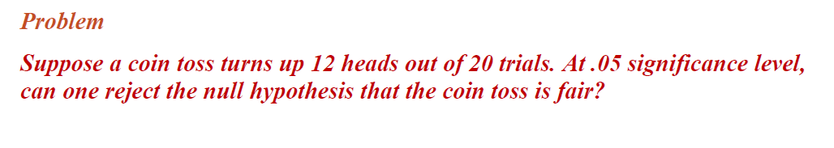

H0 : p = 0.48 (12/20) 🡪 Coin toss is fair  
H1 : p = 0.48 🡪 Coin toss is not fair



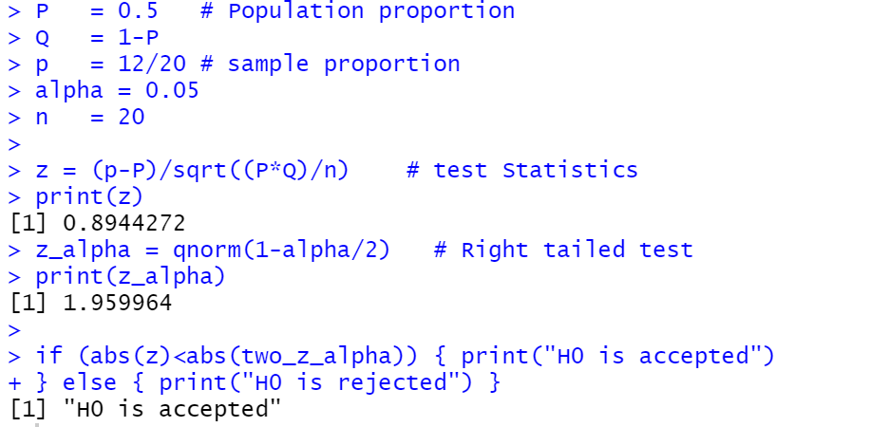

7)